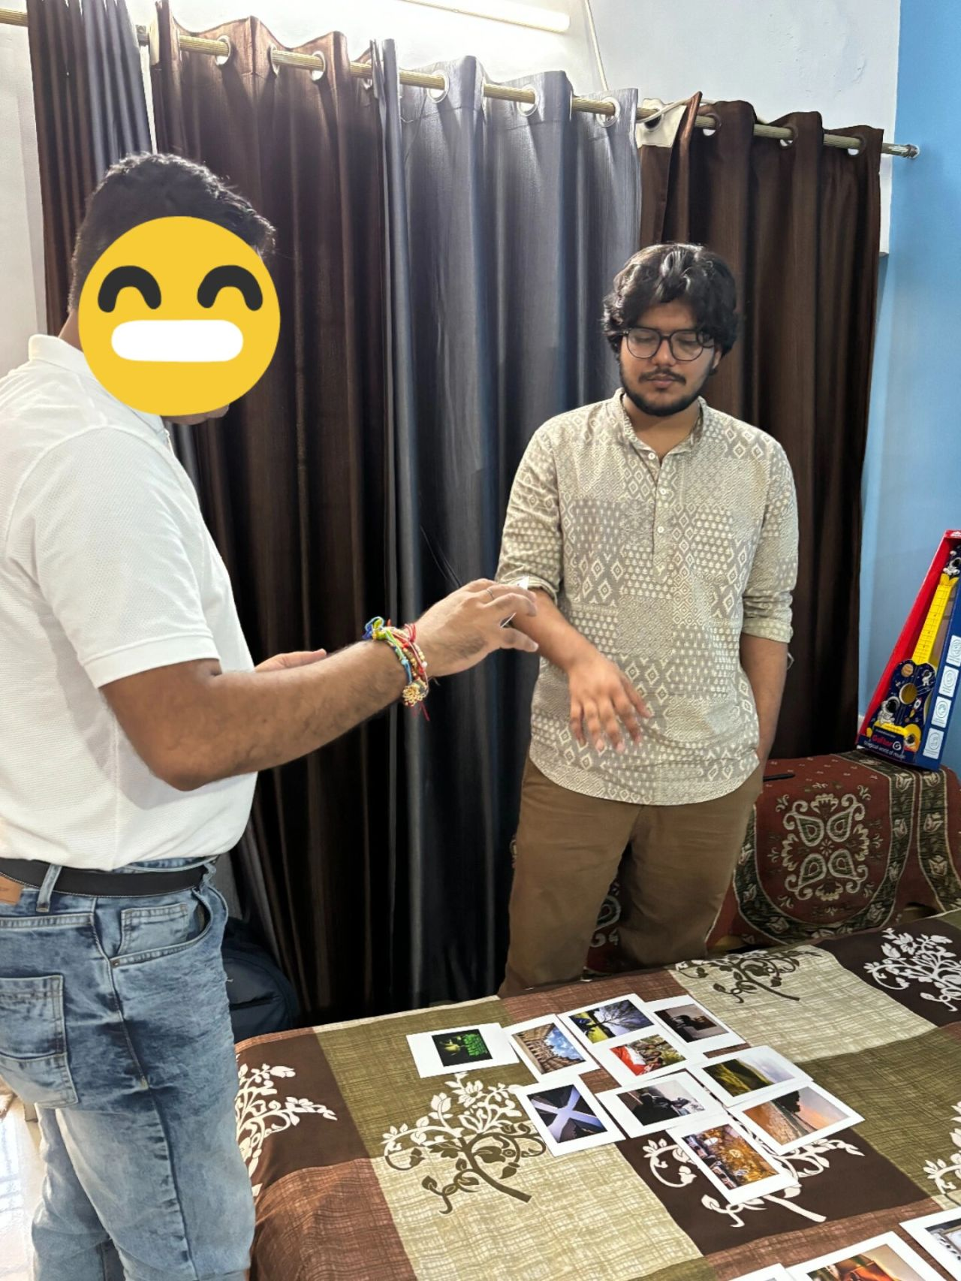
Market research / Consulting Organisations have a fundamental flaw.

And it keeps becoming more and more obvious to me as I talk to more people.

The moment a project Kickstarts, every single person in the hierarchical chain gets their own set of KPIs.

Task A, Task B, Task C is done.

Client's question 1, question 2, question 3 is answered.

and a PO is processed.

At the end of the day, it is a job right?

I do not consider myself to be in a place where I sit here challenging organisational processes - as companies go large, it almost is an inherent requirement to make roles really strict.

But from a purely research, analysis, and intervention development point of view- the process leads to massive data fidelity bleed.

How?

The Question designers frame questions, answering directly to the pain points the client perceives.

A flawed KPI. If the client's perception of the problem could have solved the problem, then they would have solved it by themselves. Respect it when smart folks reach out for help.

The moderator's KPI is to cover the DG. Ask all the questions. Get uniform transcripts.

Flawed. Every interview will have moments where the respondent would open up more giving out details fundamental to the project, but sticking only to DG questions will often break that flow of thought.

The Analyst will go through the transcript, do their thematic analysis, but by this time- the transcript is devoid of the micro-expressions, context of the responses, emotional depth and as Rishima Shetty puts it "Vibe check notes".

The Lead focuses on report design and presents it.

The transactionality built into the system is picked up by the respondent, and any good moderator is aware of the degree to which mirroring happens in an interview.

They mirror the transactionality.

Right from the beginning, the data itself becomes transactional, not human.

Empathy is a resource. It is finite. It can be exhausted.

When one only has empathy for themselves and their KPIs, how does one expect to feel for the respondent, have empathy for them, which brings out the true extent to which you can feel and capture emotions?

It was difficult for me to comprehend at first, besides the "thrill" of it, why as a college educated person who knows laws and theories and frameworks of behaviour needed to do moderation- a job terribly underpaid in the industry.

Only to later realise, every single person on the team is a proposal writer, experiment designer, moderator, analyst, writer, creative and presenter.

Our interviews keep going for 8 hours at times if the respondent wanted to keep talking, we had dinner with them if they invited us.

Every member has to be on the field. Every member has to know and "feel" the data inside out.

The involvement is built into the system.

The respect we give to the respondent leads to the respect we receive for our work.

